
Term Project-Progress Report 1

Website Chosen: Kıbrıs Gazetesi
Website URL: https://kibrisgazetesi.com Kıbrıs Gazetesi is one of the most popular news websites in the Turkish Republic of Northern Cyprus (TRNC). It provides news articles, multimedia content, and advertisements, making it an ideal candidate for a comprehensive quality assessment.
Project Members: ID: 21904531 | Name: Maaz Qureshi | Group: 2
ID: 22331350 | Name: Hasan Orkan | Group: 2
ID: 22002304 | Name: Samet Metehan Özyener | Group: 2
ID: 22701636 | Name: Saad Ahmad | Group: 1

Outline
- Cover page.......................................................................................................I
- Introduction....................................................................................................1
- Project Management Plan (timeline, work distribution, meetings) .............1-2
- Brief information about the website..............................................................2
- Testing strategy ............................................................ 2-3
- Details of your Test Plan ..........................................................................3-4
- List of Tests Performed.......................................................... 4-7
- Tests we plan to conduct in the second part of the semester.........................7
- Conclusion ......................................................................................................8
- References ......................................................................................................8

Introduction
The goal of this project is to perform multiple tests on the Kibre's Gazetesi news website to evaluate its functionality, usability, performance, security, and compatibility. By following a structured testing process, we aim to discover any issues or areas that could be improved. By identifying its strengths and weaknesses, we will also provide actionable recommendations to improve the website's quality and enhance the user experience.

Project Management Plan (timeline, work distribution, meetings)

Work Distribution:
This table presents the distribution of work among group members. Each member has been assigned different responsibilities, and the table reflects the work distributed so far in our intermediate report.

Team Members | Roles | Key Tasks
Maaz Qureshi | Project Manager/Support Tester | Organize meetings, track progress, compile reports, and assist in testing. Testing Strategies, Test Planning, Presentation
Hasan Orkan | Main Tester | Conduct main quality assurance tests, Information about the Website, and Testing Strategies.
Saad Ahmed | Support Tester | Help with test report issues, report compilation, website information, and test planning.
Samet Metehan Özyener | Report Writer/Support Tester | Format reports, assists in testing,

2. Project Timeline & Milestones & meeting schedule
We aim to complete each task on time, with team meetings scheduled at the end of each deadline period—mostly conducted via Microsoft Teams. Until the intermediate report, we will have a total of 7 meetings. Each member is expected to submit their work within the assigned timeframe, allowing others to review and provide feedback accordingly.
Tasks | Duration | Start date | End date
Selection website for testing | 2 days | 05/03/2025 | 07/03/2025
Testing strategies | 3 days | 07/03/2025 | 10/03/2025
Type of testing | 5 days | 11/03/2025 | 16/03/2025
Test plan | 3 days | 20/03/2025 | 23/03/2025
Selection test tools | 2 days | 25/03/2025 | 27/03/2025
Preparation for presentation | 6 days | 28/03/2025 | 02/04/2025
Intermediate upload | 8 days | 02/04/2025 | 10/04/2025
Final Report Submission | ? | 28/04/2025 | Upcoming

Brief information about the website
Kabri's Gazetesi is a newspaper that has been officially published since 1989 in Northern Cyprus. Now, it is on digital platforms where we can check daily news about TRNC, Turkey, the world, and Greek news, articles, sports topics, etc. Also, other than news, we can access their Live TV channel and radio through their website. The site is organized into different sections to make the header topics more accessible, such as:
- Homepage:
- In the task bar’s home page, you can see daily popular short news, some articles by authors, some short videos of their YouTube channel, daily exchange rates, and the Cyprus league scoreboard. Also, you can click the specified topic in the taskbar to see all provided things.
- Section and Categories
- TRNC: ALL daily news about TRNC provided by their newspaper
- Greek press: Highlights of Greek news
- World: International important news
- Economy: Financial news
- Sports: Sports news in Cyprus and important events in the world
- Interviews: Interviews about important events in TRNC
- All news: Section where we can see all news
- Authors: Columns and articles by authors
- Deaths: Obituaries and announcements
- Search Functionality
- The website has a search bar where a user can find articles and news by entering keywords or normal words.
- User Interaction
- Users can engage with content by commenting in the comment section and sharing it with their friends or on social media.
- Accessibility Features
- User can change and resize the text size manually
- User can change reading mode into dark or light mode
- User can easily adjust browser size without affecting layout or readability

Testing Strategy
To test this website, we are going to use the black box testing technique since we don’t have access to the code. Black box testing focuses on externally seen behaviors without access to the main code. Black box testing focuses on functionality, usability, performance, and security. With testing, we will use this approach to assess how well it meets industry standards.
We will use both manual and no-code automated testing tools to assess various critical aspects of the website. These tools will help us in evaluating the website, including how effectively it works, how secure it is, and whether it meets accessibility and usability criteria.
To assess the website's quality, we will use web testing tools. The evaluation will be based on plenty of information collected by these testing tools, which will analyze important performance indicators across multiple quality aspects. The results will provide practical knowledge about the strengths, weaknesses, and areas of this website and how well this website is.
To carry out our thorough testing strategy, we will be performing the following assessments using the following testing tools:

1. Performance Testing- —Tests page speed. GTmetrix tells you how your website performs, why it's slow, and how to optimize it. (Tool: GTMetrix https://gtmetrix.com/)
2. Accessibility Testing - helps authors make their web content more accessible to individuals with disabilities.
(Tool: WAVE: https://wave.webaim.org/).
3. Security & Vulnerability Testing - ZAP to perform security testing, even if you don’t have a background in security testing (Tool: OWASP ZAP https://www.zaproxy.org/getting-started/)
4. Cross-Browser Testing—(Tool: Lambda Test https://www.lambdatest.com/).
5. Mobile Responsiveness Testing - Testing the website in different screen sizes to see how responsive the website
(Tool: Responsive Viewer https://try.responsiveviewer.org/)
6. SEO Testing - checking for proper tags and surfacing any errors that might come up
(Tool: SEO Site Checkup https://seositecheckup.com/ )
7. Broken Link Testing scans for 404 errors and redirect chains to see where the error is.
(Tool: Dead Link Checker https://www.deadlinkchecker.com/)
8. SSL/TLS Security Testing - deep analysis of the configuration of any SSL web server on the public Internet (Tool: SSL Labs https://www.ssllabs.com/ssltest/ )
9. Cookie Testing— Validates cookie functionality (Tools: Cookie Bot https://www.cookiebot.com/)
10. Page Weight Analysis —Measure your site's carbon footprint
(Tool: Webpage Test https://www.webpagetest.org/)
11. DNS & Network Testing Checks DNS records, blacklists
(Tool: MX Toolbox https://mxtoolbox.com/)
12. Third-Party Script Testing - check the website for known malware, viruses, blacklisting status
(Tool: Secure Site Check https://sitecheck.sucuri.net/ )
13. Caching & Header Testing- —it tests protocol correctness and catchability
(Tool: Red Bot https://redbot.org/ )
14: Usability Testing— a tool for improving the performance, quality, and correctness of the website
(Tools: Google Lighthouse - https://pagespeed.web.dev/ )
15: Malware & Threat Detection— Scans for malicious content (Tools: Norton Safe Web https://safeweb.norton.com/ )
16: HTML & CSS Validation— Checks code compliance (Tools: W3C Validator: https://validator.w3.org/ )
17: Website Monitoring— Tracks uptime and performance (Pingdom Tools: https://tools.pingdom.com/ )
18: Content Testing— Verifies media and text accuracy (Tools: Power Mapper https://www.powermapper.com/)
19: A/B Testing— Compares different versions of webpages (Tools: Google Optimize)
20: Network Performance Testing— Analyzes connectivity (Tools: Wireshark https://www.wireshark.org/download.html )

Test plan
To test this website within the specified duration, some tests were performed during the initial presentation, and the execution of these tests continues to encompass and examine more details. We will conduct a total of four tests in our intermediate report, while the remaining will be included in the final report. As I mentioned, black box testing will be performed since we do not have access to any of the source code. In our intermediate report, we will conduct four tests, with additional tests planned for the final report, totaling twenty tests. Here are the tests we will perform:
- Performance Testing: We will evaluate the website’s speed and efficiency by measuring load times, identifying bottlenecks, and assessing overall optimization
- Accessibility Testing: Our goal is to ensure the website is accessible to all users, including those with disabilities.
- Cross-Browser Testing: We will ensure the website renders consistently and correctly across major browsers (e.g., Chrome, Firefox, Safari, Edge) using online tools like Lambda Test
- Mobile Responsiveness Testing: This test will verify that the website adapts seamlessly to various screen sizes and devices.

Testing Procedure We Are Going to Follow:
- Selection of Testing Tools: Start by identifying and selecting appropriate testing tools for each specific type of testing. For instance, approach E ensures
- Execution of Tests: With the tools selected, systematically conduct the tests:
- Result Evaluation: After completing the tests, analyze the collected data to extract meaningful insights. Compare the results against established benchmarks or industry standards to assess performance.
- Recommendations for Improvement: Make recommendations for enhancements that can improve security, accessibility, and performance.

List of Tests Performed, the website's quality, and recommended improvements.

1: Performance Testing
Selection of the Tools Used:
- Tool Selected: Gemetrix
Execution of Tests:
Testing Type: Automation testing (online tools)
Tested Setups:
- GTmetrix is used to run a performance test on the target page.
Result Evaluation:
Image We took it from the GTmetrix website:
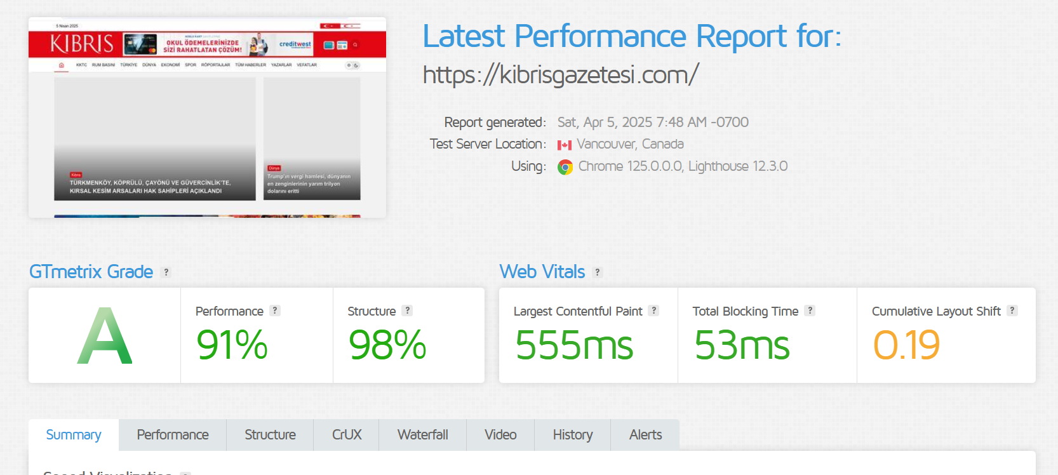
The GTmetrix report shows that the website achieved an overall performance grade of A, which is really good, with a performance score of 91% and a structure score of 98%. The largest contentful paint is recorded at 555 MS, ensuring that the main content loads quickly, while the total blocking time (TBT) is only 53 MS, showing a highly responsive user experience. The Cumulative Layout Shift (CLS) stands at 0.10, showing stable and reliable page rendering. Also, the page size is approximately 1.46 MB, with 38 requests made during the loading process, culminating in a total load time of about 0.8 seconds.
Recommendations for Improvement: Consider specifying dimensions for images and ads to further reduce any potential layout shifts.

2: Accessibility Testing
Selection of the tools used:
- Tool Selected: Wave (online)
Execution of Tests:
Testing Type: automation Testing
The test was conducted by entering the website’s URL into the WAVE tool and analyzing both the visual output and HTML structure.
Result Evaluation:
Image, we take it from the website:
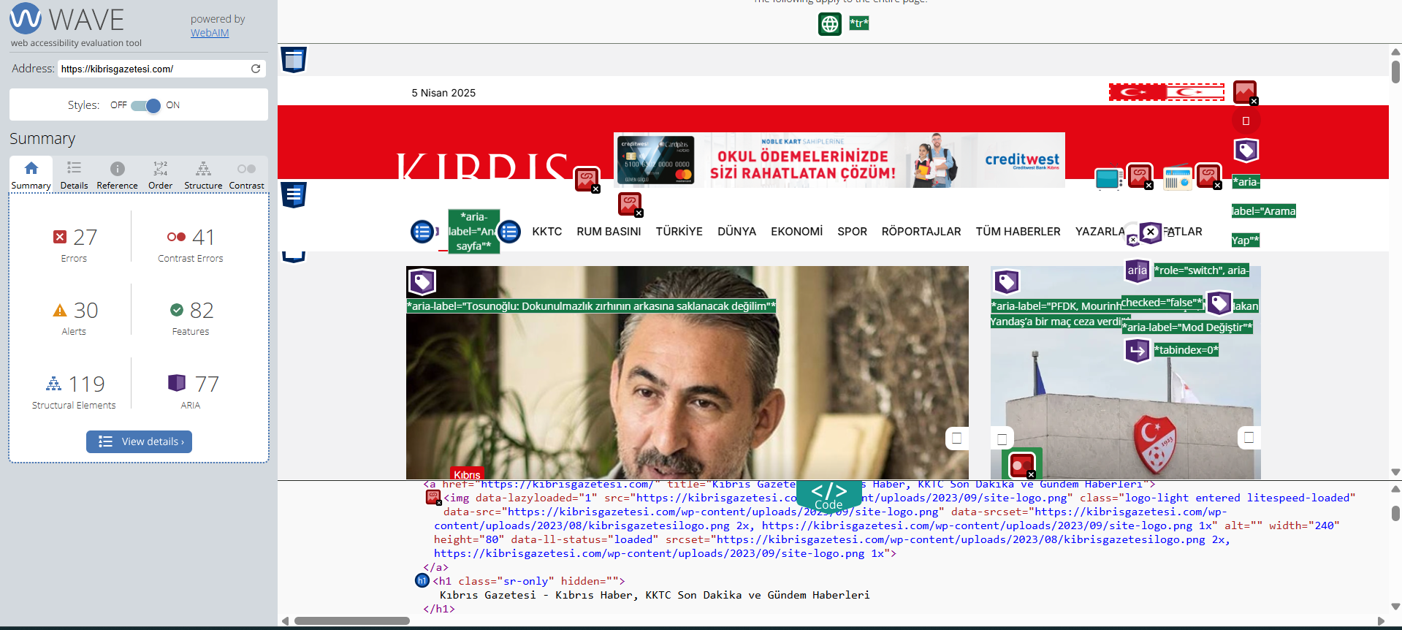
The WAVE report revealed that the site contains 27 accessibility errors and 41 contrast errors. These may include missing alternative text for images, unlabeled buttons or form elements, as well as poor color contrast ratios that hinder readability. In addition, the website shows 30 alerts, which suggest potential accessibility concerns needing manual review. On the positive side, the website has 82 accessibility features, 119 structural elements, and 77 ARIA labels, proving that accessibility has been given a look. However, due to the critical errors and contrast problems, the site still needs some usability improvement, or else it will be challenging for people relying on screen readers.
Recommendations for Improvement:
To improve accessibility, key problems such as missing labels, alt attributes, and contrast errors should be fixed. Manual checks should also be done to ensure screen reader and keyboard support. These steps will improve user experience and align the site with accessibility standards.

3. Cross-Browser Testing
Selection of the Tools Used:
- Tool Selected: Lambda Test
Execution of Tests:
Testing Type: Manual Testing (Live interactive testing)
Tested Setups:
- Windows 11 + Google Chrome.
- macOS Sequoia + Safari .
Functionalities we checked and tested:
- Navigation Menus: Click-through functionality and visual alignment.
- Buttons: Interaction and responsiveness.
- Night Mode: Toggle functionality and visual consistency
- Page Layout: Element positioning, text formatting, and spacing.
Result Evaluation:
Imagine we took macOS:
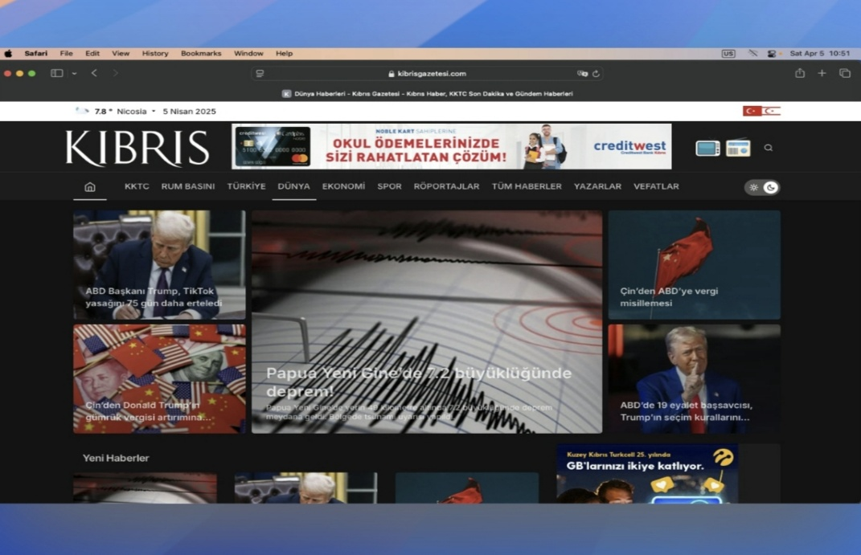
For our checks, we picked specific setups. One was Windows 11 with Google Chrome. Another was macOS Sequoia with Safari.
With Lambda Test's live testing, we looked at the website at that moment. We then clicked on different parts like navigation menus and buttons. We tested night mode and page responsiveness.
Through the tests, we found no problems with the layout, non-working features, or platform differences. The website had the same look plus actions on both setups. This showed it possessed cross-browser compatibility
Recommendations for Improvement: Suggestions might include adjusting CSS media queries or optimizing element sizes to ensure a bad experience on both mobile and desktop environments

4: Mobile Responsiveness Test:
1. Testing Tools & Devices
Selection of the Tools Used:
- Responsive Design Checker (online tool).
- Google Chrome Developer Tools (manual testing).
Execution of Tests:
Tested Devices:
- Samsung Galaxy S20
- iPhone 14 Pro
- iPad Air
- Desktop Screen
Functionalities and UI components that have been tested:
- Page Layout: Confirmation of the general alignment and structure
- Verify the readability and appropriate scaling of the text format and size.
- Buttons: Verify that interactive components are usable and accessible.
- Taskbar/Menu: Verify proper display and seamless navigation.
- Overall Visual: Assess the coherence and beauty of the design.
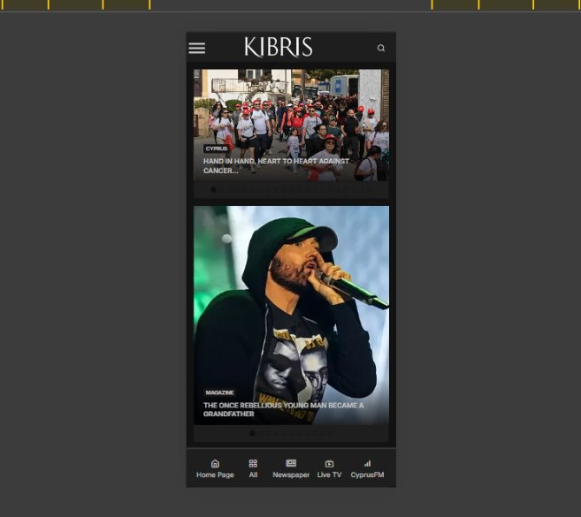

Result Evaluation:
Each functionality worked correctly with the devices, as with computer devices. The website appeared to be suited for mobile use. Content resized as expected, navigation flowed well, and no usability or design troubles surfaced. Because of these features, the website is mobile responsive and gives smartphone users a positive experience.
Recommendations for Improvement: No significant changes are needed, but it is advised to keep an eye on things constantly to ensure optimal performance when new gadgets or updates are released.

Tests are planned for the final report.
We have completed four tests so far. The remaining tests will be conducted and included in our final report. However, there is a possibility that the number of tests may be slightly reduced due to page size limitations, and the testing we are going to do is the following: Security & Vulnerability Testing, SEO Testing, Broken Link, SSL/TLS Security Testing, Cookie Testing, Page Weight Analysis, DNS & Network Testing, Third-Party Script Testing, Caching & Header Testing, Usability Testing, Malware Threat Detection, HTML & CSS Validation Testing, Website Monitoring, Content Testing, A/B Testing, Network Performance Testing, and Link Testing.

CONCLUSION
At this project stage, we start testing on the Kibre's Gazetesi website. We focus on testing the performance, accessibility, cross-browser compatibility, and mobile responsiveness. Our analysis showed the website's speed and responsiveness are good; it has an excellent GT-Metrix score, and load times are fast. Cross-browser testing proved that the user interface is most likely the same on all platforms. Mobile responsiveness tests gave an easy user experience across all screen sizes; it was excellent. Accessibility testing gave us several errors and some contrast issues that could affect usability for the users who rely on reader features. We recommend the developers fix these problems and the errors the website has, and the missing labels and alternative text for the image, to avoid any problems for the users of the website.
In the future, we intend to execute further tests; this includes security, SEO, broken link detection, and usability, along with content validation. The details from these tests will help us make a detailed final report. The report will have specific advice to improve the overall website quality and security.

REFERENCES
GTmetrix. GTmetrix. https://gtmetrix.com

WAVE. Web Accessibility Testing Tool. https://wave.webaim.org

W3C. Web Content Accessibility Guidelines (WCAG) 2.1. https://www.w3.org/TR/WCAG21/

